Keyboard Assessment
Student Visual Aid

Name: ___________________ Grade: ____ Teacher: ___________

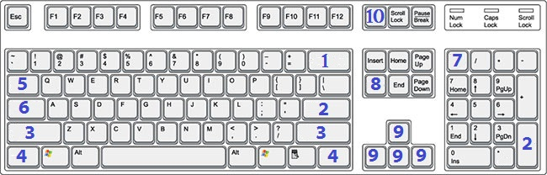
Directions: Use the image of the keyboard above to locate each number. Use the list of keyboard keys below to name each key. Write the number of the correct key on the line next to the correct number.
1. _______
2. _______
3. _______
4. _______
5. _______
6. _______
7. _______
8. _______
9. _______
10. _______
- Shift Key
- Backspace Key
- Delete Key
- Caps Lock Key
- Ctrl Key
- Enter Key
- Arrow Keys
- Tab Key
- Print Screen Key
- Number Lock Key (NumLk)

