Name:
I can type plural words by adding an S at the end of a singular word.
Singular Word (ONE)  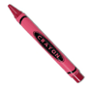  Example | Plural Word (MORE THAN ONE)  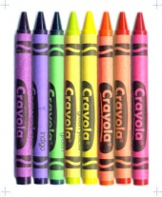
mop | mops
fin
log
pat
lid
nut
red
pan

I can type sentences.

