Name:
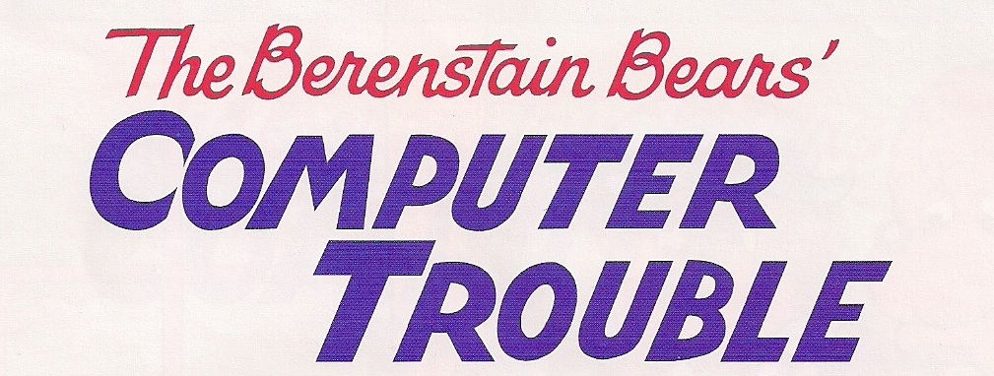

Internet Safety Suggestions for Cubs and Kids:
1.
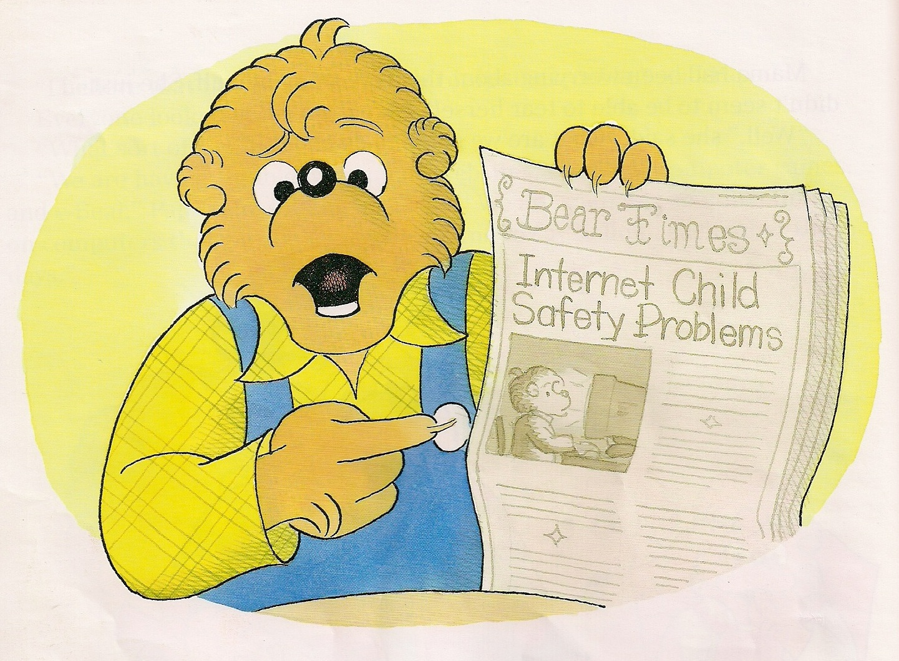
2.
3.
4.
5.
6.
7.
8.
9.
10.

